1. **Installation Steps:**
2. **SQL server: Oracle Express edition 18c:**
3. Go to the [official website](https://www.oracle.com/in/database/technologies/xe-downloads.html#license-lightbox) of Oracle and in the “Applications” section, select the “Express Edition 18c” (64 bit, Win)
4. Download the zip file and extract the contents.
5. In the extracted folder, there is an installer application “Setup.exe”. Run it giving the administrator permission.
6. The software will ask for a password for default database users i.e. SYSTEM, SYS, PDBADMIN. Remember the password used here. 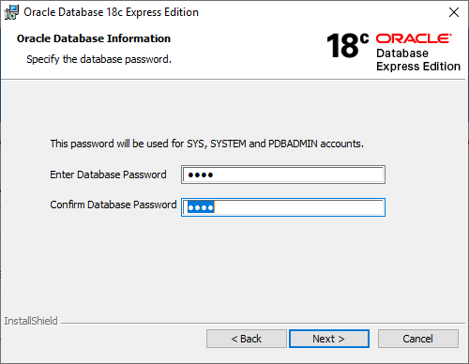
7. Then give a directory path for the setup files to be installed. 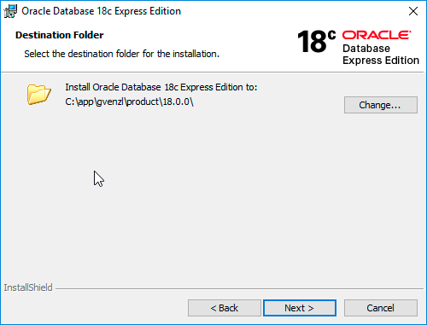
8. Check for the desired paths and hit “Install”. 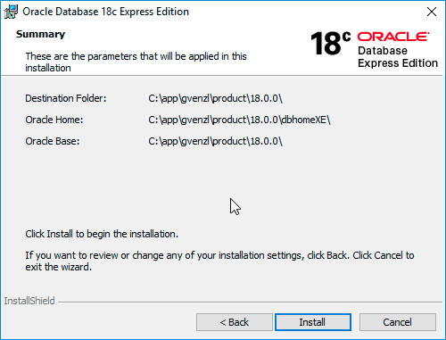
9. The installation will take about 15-20 minutes. 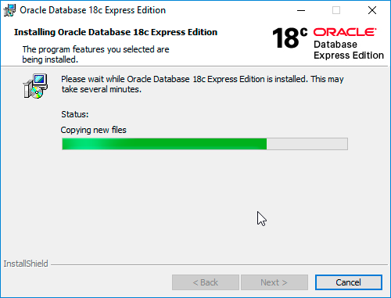
10. If you get an error during this process, follow the procedure given in ‘Section B’ of this document.
11. **SQL client: Oracle SQL developer**
12. Go to the official website of Oracle SQL Developer
13. Download the zip file for your OS and version.
14. Extract the files.
15. In the extracted files, the ‘sqldeveloper’ application is the SQL client.

**B. Configuration Settings:**